URL : https://www.webslesson.info/2020/01/how-to-create-autocomplete-textbox-using-php-with-jquery-ajax.html

How to Create AutoComplete Textbox using PHP with jQuery Ajax
Webslesson 23:16 autocomplete, autocomplete search, autocomplete textbox, autocomplete textbox jquery, JQuery, jquery autocomplete, jquery autocomplete from database, mysql, php No comments

Do you know what is AutoSuggest or AutoComplete textbox? The AutoSuggest Textbox means when user has type in search textbox, then they can get quickly get result according what they has type in search box, and they can select value form pre populated search suggestion from the list. This AutoSuggestion feature will load suggestion automatically, when user has type some character into Search textbox field. Here we will make lightweight AutoSuggest or AutoComplete textbox by using PHP script with Mysql Database, jQuery and Ajax.
Now in your mind one question will arise, How it called light weight AutoSuggest Textbox. This is because here when user has type in search textbox, then it will only one time fetch data from Mysql database, and then after by using jQuery plugin it will filter data from data which has fetch from database and display filter result in AutoSuggest search result. So, Here we have called this light weight AutoSuggest or AutoComplete Textbox, because it is only send one request to Mysql database and fetch data and by using jQuery plugin it has filter result from that data and display as AutoSuggest result below Search box.
In Most of AutoComplete or AutoSuggest tutorial, we have seen on every character type, it has send request to Mysql database using Ajax and display search result, but In this tutorial, it will only send one Ajax request to Mysql database and then after data will be filter by using jQuery and display one web page. For make this tutorial, here we have use jQuery "JsLocalSearch" plugin, which is very light weight and fast jquery plugin, which used for filter records from client side data and which is mainly used for filter and search a of element which we have provide. It main feature is to search html content which we have provide. Below you can find source code of How to make AutoSuggest Textbox with Bootstrap library by using PHP script with jQuery Ajax and Mysql database.
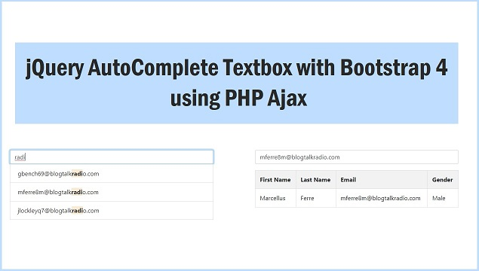

Database

--
-- Database: `testing`
--

-- --------------------------------------------------------

--
-- Table structure for table `customer_table`
--

CREATE TABLE `customer_table` (
`customer_id` int(11) NOT NULL,
`customer_first_name` varchar(200) NOT NULL,
`customer_last_name` varchar(200) NOT NULL,
`customer_email` varchar(300) NOT NULL,
`customer_gender` varchar(30) NOT NULL
) ENGINE=InnoDB DEFAULT CHARSET=latin1;

--
-- Indexes for dumped tables
--

--
-- Indexes for table `customer_table`
--
ALTER TABLE `customer_table`
ADD PRIMARY KEY (`customer_id`);

--
-- AUTO_INCREMENT for dumped tables
--

--
-- AUTO_INCREMENT for table `customer_table`
--
ALTER TABLE `customer_table`
MODIFY `customer_id` int(11) NOT NULL AUTO_INCREMENT;

Online Demo

index.php

<!DOCTYPE html>
<html>
<head>
<title>jQuery Auto Suggest Textbox with Bootstrap 4 using PHP Ajax</title>
<script src="https://code.jquery.com/jquery-1.12.4.min.js"></script>
<script src="https://cdnjs.cloudflare.com/ajax/libs/popper.js/1.12.9/umd/popper.min.js"></script>
<script src="https://maxcdn.bootstrapcdn.com/bootstrap/4.0.0/js/bootstrap.min.js"></script>
<script src="JsLocalSearch.js"></script>
<link rel="stylesheet" href="https://maxcdn.bootstrapcdn.com/bootstrap/4.0.0/css/bootstrap.min.css" />
<style>
.mark {
background-color: #d7ffe7 !important
}

.mark .gsearch{
font-size: 20px
}

.unmark {
background-color: #e8e8e8 !important
}

.unmark .gsearch{
font-size: 10px
}

.marktext
{
font-weight:bold;
background-color: antiquewhite;
}
</style>
</head>
<body>
<br />
<br />
<div class="container">
<h3 align="center">jQuery Auto Suggest Textbox with Bootstrap 4 using PHP Ajax</h3>
<br />
<br />
<div class="row">
<div class="col-md-3"></div>
<div class="col-md-6">
<input type="text" id="gsearchsimple" class="form-control input-lg" placeholder="Search..." />

<ul class="list-group">

</ul>
<div id="localSearchSimple"></div>
<div id="detail" style="margin-top:16px;"></div>
</div>
<div class="col-md-3"></div>
</div>
</div>
</body>
</html>
<script>
$(document).ready(function(){
$('#gsearchsimple').keyup(function(){
var query = $('#gsearchsimple').val();
$('#detail').html('');
$('.list-group').css('display', 'block');
if(query.length == 2)
{
$.ajax({
url:"fetch.php",
method:"POST",
data:{query:query},
success:function(data)
{
$('.list-group').html(data);
}
})
}
if(query.length == 0)
{
$('.list-group').css('display', 'none');
}
});

$('#localSearchSimple').jsLocalSearch({
action:"Show",
html_search:true,
mark_text:"marktext"
});

$(document).on('click', '.gsearch', function(){
var email = $(this).text();
$('#gsearchsimple').val(email);
$('.list-group').css('display', 'none');
$.ajax({
url:"fetch.php",
method:"POST",
data:{email:email},
success:function(data)
{
$('#detail').html(data);
}
})
});
});
</script>

fetch.php

<?php

//fetch.php;

$connect = new PDO("mysql:host=localhost; dbname=testing", "root", "");

if(isset($_POST['query']))
{
$query = "
SELECT DISTINCT customer_email FROM customer_table
WHERE customer_email LIKE '%".trim($_POST["query"])."%'
";

$statement = $connect->prepare($query);

$statement->execute();

$result = $statement->fetchAll();

$output = '';

foreach($result as $row)
{
$output .= '
<li class="list-group-item contsearch">
<a href="javascript:void(0)" class="gsearch" style="color:#333;text-decoration:none;">'.$row["customer_email"].'</a>
</li>
';
}

echo $output;
}

if(isset($_POST['email']))
{
$query = "
SELECT * FROM customer_table
WHERE customer_email = '".trim($_POST["email"])."'
LIMIT 1
";

$statement = $connect->prepare($query);

$statement->execute();

$result = $statement->fetchAll();

$output = '
<table class="table table-bordered table-striped">
<tr>
<th>First Name</th>
<th>Last Name</th>
<th>Email</th>
<th>Gender</th>
</tr>
';

foreach($result as $row)
{
$output .= '
<tr>
<td>'.$row["customer_first_name"].'</td>
<td>'.$row["customer_last_name"].'</td>
<td>'.$row["customer_email"].'</td>
<td>'.$row["customer_gender"].'</td>
</tr>
';
}
$output .= '</table>';

echo $output;
}

?>

